Metadata classes, metadata objects and Data Objects
The 1C:Enterprise platform provides a number of business components that make it easy to build an applied solution. We call these business components metadata classes. A list of metadata classes is predefined by the platform and it can be seen in the configuration tree at Designer mode:
- Catalogs
- Documents
- Enumerations
- Charts of characteristic types
- Reports
- Data processors
- Information registers
- Accumulation registers
- Business processes
- Subsystems
- Roles
- and many others
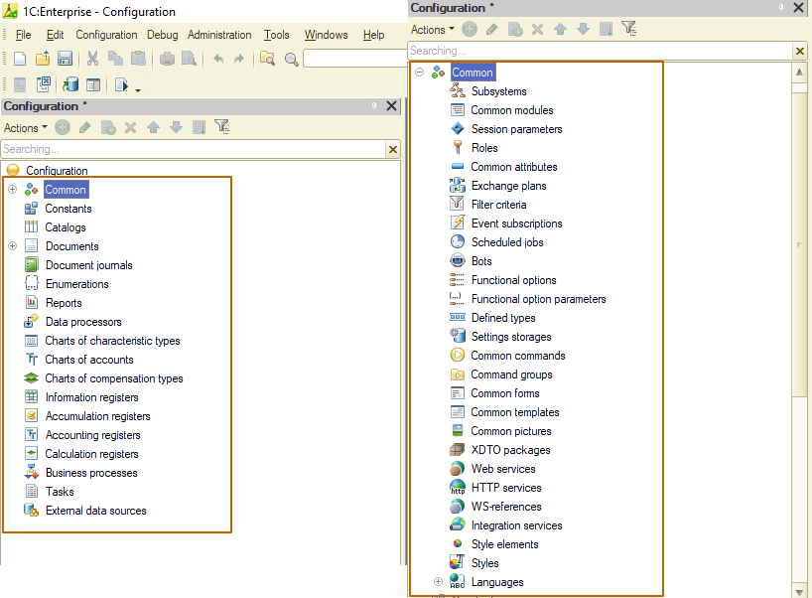
Metadata classes (on the right side – metadata classes inside “Common” branch)
Metadata classes are similar to OOP (object-oriented programming) classes with the difference that we cannot create our own metadata classes. But we can create as many metadata objects as we want for each metadata class.
Let's look at an example to better understand these objects. We can compare the configuration with a factory producing household appliances and electronics:
- TVs
- phones
- laptops
- vacuum cleaners
- other
Each of these types of technology has common characteristics: every cell phone must be able to make and receive calls, every laptop must have a keyboard and a screen, and so on.
The metadata classes at the configuration also have common characteristics: standard attributes (all documents contain the attributes "date", "number", all catalogs contain the attributes "code", "parent", etc.), events (documents have events related to Posting operation), behavior (user visibility, access to objects depending on user roles, etc.). 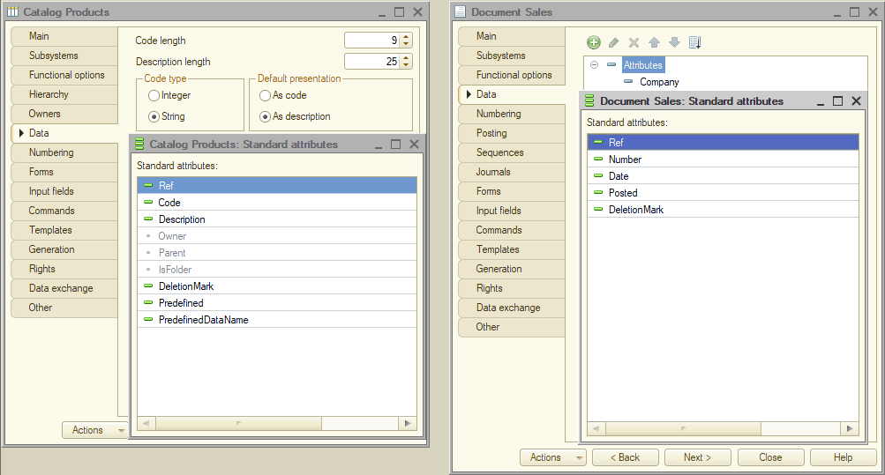
Standard attributes of catalog and document
So, to start production of some device, we first should choose a type of it. For example, we want to produce YouPhone 14 pro max. We have chosen the "phone" type, now we need to specify what brand it will be, what size of the display, etc. To do this, we creating an instance of the template (a metadata object of a certain metadata class).
This is still not a specific phone, but some detailed template for creating phones of a certain series. After we choose the color, the amount of memory and the unique number of the device, it will be some particular phone. In the 1C:Enterprise system, such a single instance is a data object.
Let’s look at the implementation of this sequence at 1C:Enterprise. We want to register information about the sales of goods by our company. To do this, we select the "documents" metadata class and create an object of this class – document “Sales”.
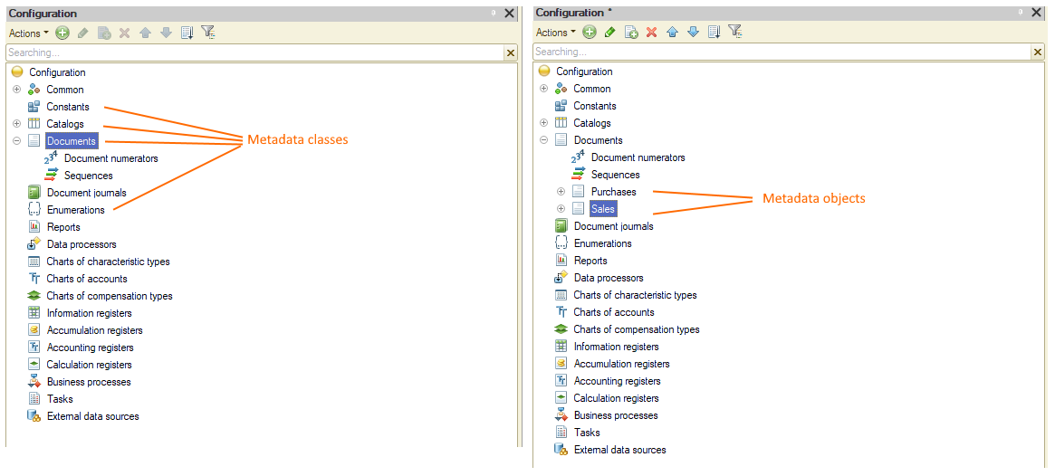
This object should contain information about the company, product, quantity and price, so we add the appropriate attributes to store this information at the “Sales” document.
Now everything is ready to create data objects. This part can be performed by the user at Enterprise mode. After filling in all the necessary information, we have a specific document with information about sale.
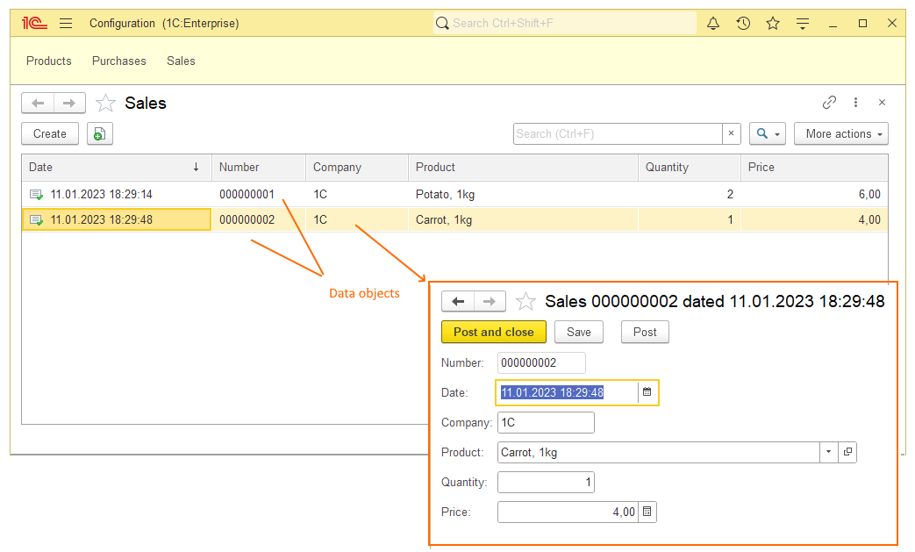
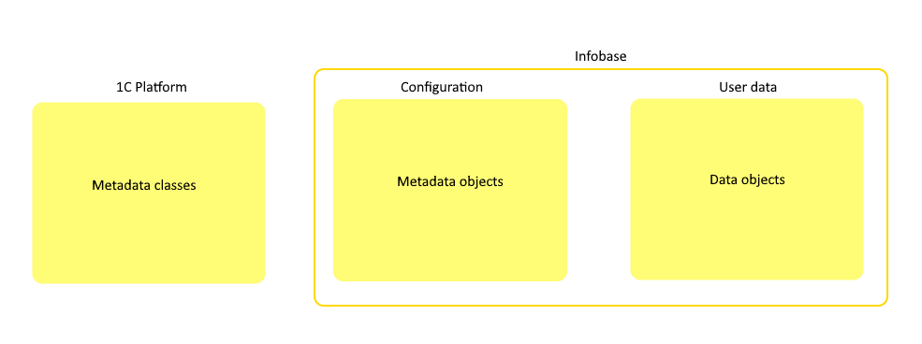

Objects and references
In the previous section we saw how a data object is created. When we open a form of a specific item of catalog, document, or other object entity (we'll learn more about object entities later), we're working with the object itself. We can make changes that will be saved to the infobase when the object is written (you can also not write changes, then the object will remain unchanged).
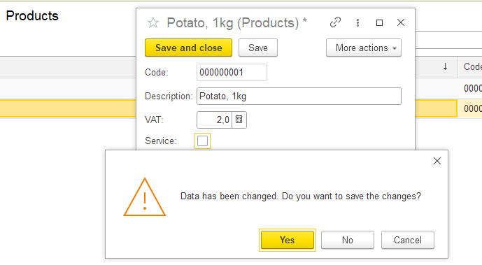
When we want to create relations between metadata objects, we use references to data objects. As you can see at the picture below, I chose a CatalogRef.Products type for attribute “Product” of “Sales” document. Now I can select one of the “Products” catalog’s element at the “Product” field. 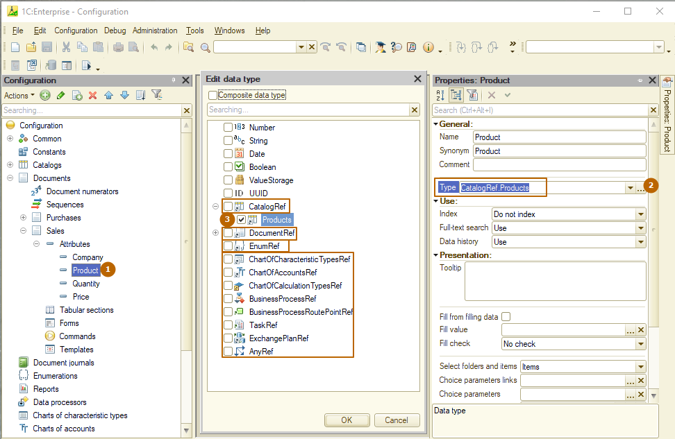
Selection of reference type at a designer mode
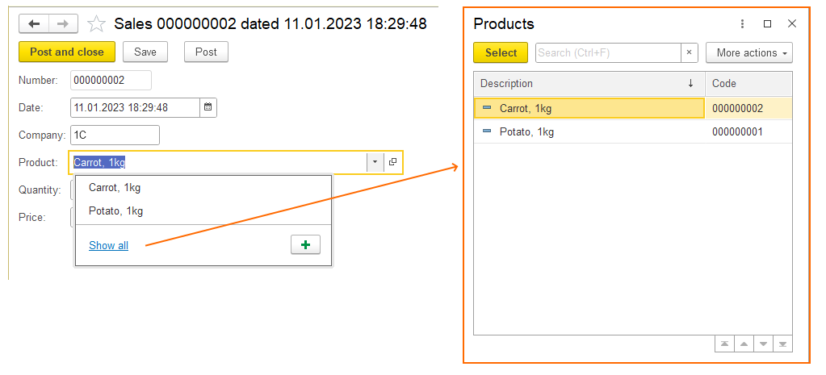
Reference to data object at an enterprise mode
A reference points to an instance of the object (data object), so changing the object does not lead to changing of values that store reference. But if an attribute used as the presentation of a reference is changed at the data object, then the presentation will be changed.
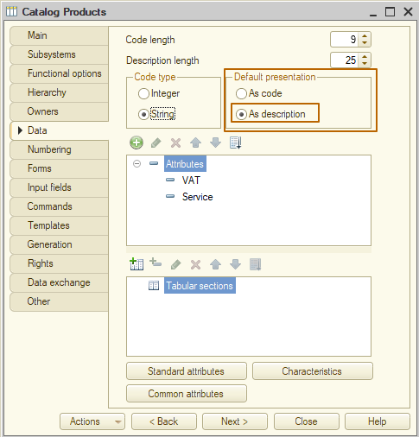
Default presentation settings of the “Products” catalog
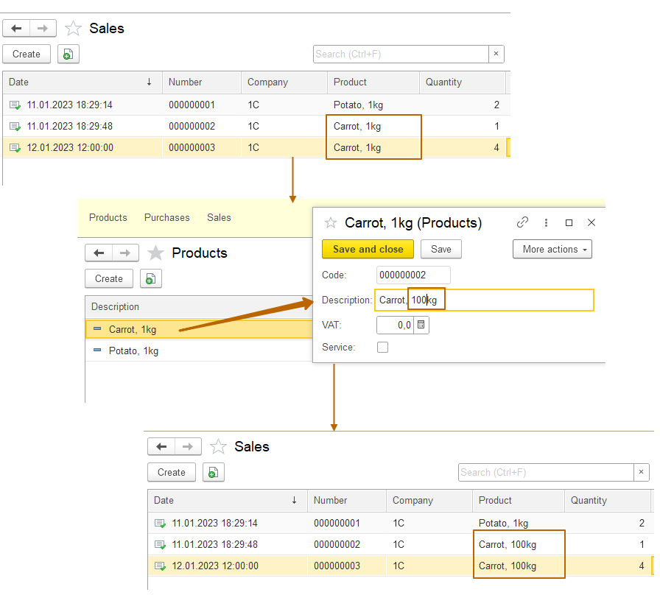
Changing of an attribute, that serves as a presentation of the “Products” catalog
It is important to understand that it does not matter where the data object was opened from: from the list, from the attribute of another object, via a direct link, etc. An object exists in a single instance and its change will affect all objects referring to it. For example, turning off the attribute "service" in some object of the "Products" catalog can distort the data for the entire infobase, since the logic for services is significantly different from goods - services are not stored in a warehouse, do not have a lot number, etc.
Another important detail is that it is impossible to make changes to a data object through a reference.

Primitive types
It's time to take a closer look at types at 1C:Enterprise. Let's start with primitive types, these are: number, string, date and Boolean (true/false).
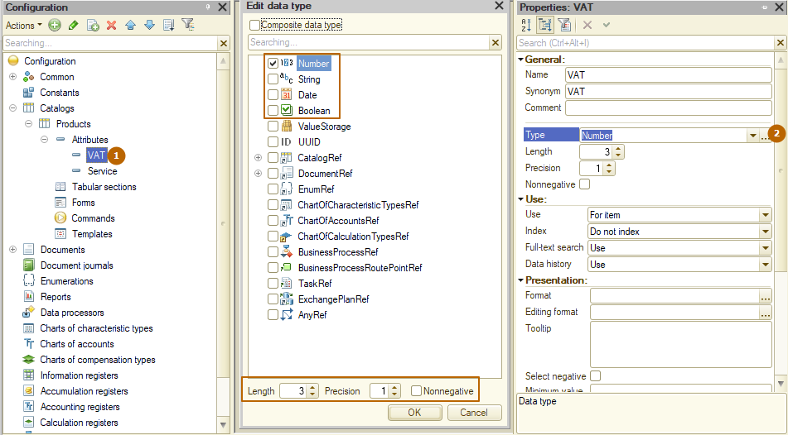
A number has 3 properties:
- Length – length (number) of all digits
- Precision - length (number) of the fractional part
- Nonnegative - sign of non-negativity
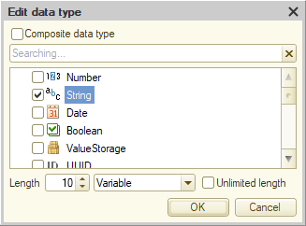
A string also has three properties:
- Length - number of characters (if 0 then the “Unlimited length property will be automatically turned on)
- Type of length. Fixed - if the number of characters is less than the length then string’s length will be increased to the specified length by adding spaces. Variable – the length of the string can be any within the given length.
- Unlimited length. The length of a string can be any without restrictions. Strings of unlimited length cannot be used in comparisons.
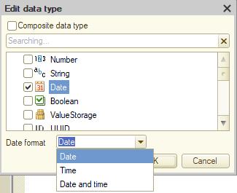
A date contains a single property – “date format”:
- Date. Date presentation for a user does not contain the time part (01/01/2000)
- Time. Date presentation for a user does not contain the date part (12:00:00)
- Date and time. Full date representation (01/01/2000 13:00:00)
* A value of a date attribute always contains the full date (date and time) regardless of the format. A value with the “date” format always contains time of a beginning of the day (01/01/2000 00:00:00).
A boolean type has no properties. It is the simplest type with only 2 options: true or false.

